Name: ______________________________ Class: _______________________ Date: ______________________

“The Moustache”: Pre-Reading Activity

Directions: Read the text below, then record your response to the prompt in the space provided. Be prepared to share your thoughts.

As people get older, everybody loses some of their ability to remember and think. It is a normal part of aging. However, some people develop a disease called dementia that causes them to lose their memory and cognitive abilities much quicker than expected.  There is no known cure for the disease, and about 10% of all people can expect to develop dementia in their lifetimes. About half of all people over 85 have dementia.  With this in mind, consider this statement: | 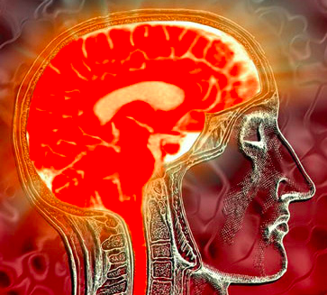  “Brain” by Laura Dahl is licensed under CC BY-NC 2.0.

A good memory is more important than a strong body.

Do you agree or disagree with this statement? Explain your perspective.

__________________________________________________________________________________________

__________________________________________________________________________________________

__________________________________________________________________________________________

__________________________________________________________________________________________

__________________________________________________________________________________________

__________________________________________________________________________________________

